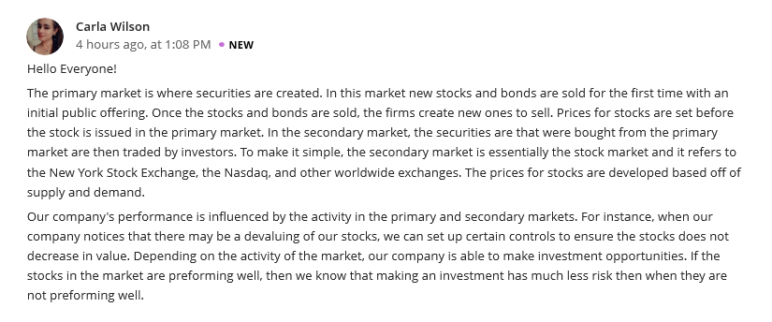
Reply 1
Hi Wilson,
You are absolutely right! Knowing how particularly the primary and secondary markets work and how they relate to individual investors is key in understanding how bonds, stock and other securities trade. Without a critical understanding of these two aspects, then navigating the capital market will be hard and the profit level will as well be low. For example, businesses and governments that want to generate debt capital can choose to issue new short and long term bonds on the primary market. New bonds are issued with coupon rates that correspond to the current interest rates at the time of issuance, which may be higher or lower than preexisting bonds. We can therefore agree that, having a clear understanding of how these factors do interact, remains to be an important aspect in the prosperity of the market economy at large.

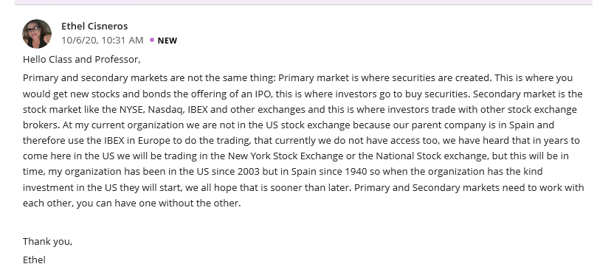
Reply 2
Hi Ethel
I absolutely agree with you, primary and secondary markets need each other and they have to work with each other. It’s equally good to have a general understanding of the market's structure. The way in which securities are brought to the market and traded on various exchanges is central to the market's function. Just imagine if organized secondary markets did not exist; you'd have to personally track down other investors just to buy or sell a stock, which would not be an easy task.
Similarly, I believe there is need for the organization you are working on to adopt the New York stock Exchange or National stock Exchange, though that will come with a variety of challenges.

